
King Khalid University,
Department of Information Systems, Applied College, Mahayil Asir

Diploma Programme in Information Systems

Applied Project
Wajhati Saudiya: Smart Tourism Application in the Kingdom of Saudi Arabia
Submitted By:
Student Name | Student ID
Saleha Ahmed Al-Hilali | 446813061
Abrar Ahmed Al-Asmari | 446817787
Amjad Fahad | 446815639
Razan Ali Al-Asmari | 446808078
Fatimah Amer Hassan Al-Barqi | 446815558
Layla Muhammad Ibrahim | 446807557
Jory Yahya Mohammed | 445805103
Noora Ali | 446808449

Supervised By: Dr. Khalid Mahmood Ali Asghar
---------------------------------------------------------------------

ABSTRACT
Tourism in the Kingdom of Saudi Arabia is growing rapidly and plays an important role in achieving the goals of Saudi Vision 2030. However, many domestic travelers still face difficulties when planning their trips because tourism information is scattered across different websites and applications. Most existing platforms provide general information and do not offer personalized trip planning based on user preferences.
This project presents Wajhati Saudiya, a smart tourism application designed to support domestic trip planning inside Saudi Arabia. In the first phase, the system will be developed as a mobile application. In the second phase, it will be expanded into a web application to increase accessibility and allow users to plan trips from different devices.
The system allows users to enter their preferences such as destination city, trip duration, budget range, trip type (family, adventure, cultural, leisure), and personal interests. Based on these inputs, the application generates a customized day-by-day itinerary using an AI-based recommendation engine. The system also integrates a centralized tourism database, interactive maps and route optimization, cost estimation, itinerary modification, favorites management, reviews and ratings, seasonal notifications, and an AI assistant to support users during the planning process.
The project follows an Agile development methodology and focuses on both functional and non-functional requirements such as usability, performance, security, reliability, scalability, and Arabic-first language support. The expected outcome is an intelligent and user-friendly tourism planning system that reduces time and effort, improves user satisfaction, and contributes to promoting domestic tourism in Saudi Arabia.

ACKNOWLEDGMENT

We want to thank everyone who making it possible for students like us. And we would like to express our deepest gratitude to "Allah" firstly,
and then to Dr. Khalid Mahmoud, our project supervisor, for his invaluable advices, guidance and his enormous patience throughout the development of the research, and useful critiques of this research work.
We would like to express our gratitude towards our parents for their kind cooperation and encouragement which helped us in finishing this project. And a special thanks to everyone with whom we have reached this stage, especially the faculty members in the college whom we met during our studies.

COMMITTEE REPORT

We certify that we read this graduation project report as examining committee, examined the students’ project in its content and that in our opinion it is adequate as a report document for Diploma in Information Systems.

Supervisor: …………………………, Signature ……………, Date: / /
Examiner 1: ………………………, Signature………………, Date: / / Examiner 2: ………………………, Signature ………………, Date: / /

Table of Contents
Diploma Programme in Information Systems - 1 -
Applied Project - 1 -
ACKNOWLEDGMENT - 3 -
COMMITTEE REPORT - 4 -
INTRODUCTION - 7 -
1.1 Introduction - 8 -
1.2 Previous Work - 8 -
1.3 Problem Statement - 9 -
1.4 Scope - 9 -
1.5 Objectives - 10 -
1.6 Advantages - 10 -
1.7 Disadvantages - 10 -
1.8 Software Requirements - 10 -
1.9 Hardware Requirements - 11 -
1.10 Software Methodology - 11 -
1.11 Project Plan - 12 -
LITERATURE REVIEW - 13 -
2.1 Introduction - 14 -
2.2 Related Work - 14 -
2.2.1 Similar Systems - 14 -
Chapter 3 - 17 -
SYSTEM ANALYSIS - 17 -
3.1 Introduction - 18 -
3.2 Data Collection Method - 18 -
3.3 Requirements Elicitation - 18 -
3.3.1 Functional Requirements - 18 -
3.3.2 Non-Functional Requirements - 19 -
Register - 21 -
Login - 21 -
Manage Profile / Language - 22 -
Enter Trip Preferences - 22 -
Generate Itinerary - 22 -
View Itinerary (day-by-day) - 23 -
Modify / Regenerate Itinerary - 23 -
View Attraction Details - 23 -
View Map & Routes - 23 -
Save Favorites - 24 -
View Reviews & Ratings - 24 -
Add Rating / Review (optional) - 24 -
View Trip History - 24 -
Receive Notifications - 25 -
Chat with AI Assistant - 25 -
Recommend Attractions (Included) - 25 -
Optimize Route (Included) - 26 -
CHAPTER 4 SYSTEM DESIGN - 28 -
4.1 Introduction - 29 -
4.2 Structural Static Models - 29 -
4.2.1 Class diagram - 29 -
4.3 Dynamic Models - 30 -
4.3.1 Sequence diagram - 30 -
4.3.2 Activity Diagram - 33 -

Chapter 1

INTRODUCTION

1.1 Introduction
Tourism has emerged as one of the most important and rapidly growing sectors in the Kingdom of Saudi Arabia. In recent years, the tourism industry has received significant national attention due to its contribution to economic diversification, job creation, cultural exchange, and sustainable development. This transformation aligns with Saudi Vision 2030, which aims to diversify income sources, reduce dependence on oil, and enhance the quality of life by strengthening non-oil sectors, particularly tourism.
The Kingdom has launched several large-scale tourism initiatives such as NEOM, The Red Sea Project, AlUla, and Diriyah Gate. These projects reflect the government’s commitment to developing tourism infrastructure and positioning Saudi Arabia as a leading global destination. In addition to attracting international tourists, Vision 2030 also emphasizes strengthening domestic tourism, encouraging citizens and residents to explore local destinations and support local businesses.
At the same time, technological advancements have significantly changed how people plan and experience travel. Travelers increasingly depend on web and mobile applications to search for destinations, organize itineraries, manage travel budgets, and navigate unfamiliar places. Smart tourism applications leverage technologies such as Artificial Intelligence (AI), data analytics, and location-based services to deliver personalized and interactive travel experiences.
Despite the availability of various tourism platforms, travelers within Saudi Arabia still face challenges in planning organized and personalized trips. Tourism information is often scattered across multiple platforms, and most existing applications provide general information without offering intelligent recommendations tailored to user preferences.
To address these challenges, this project proposes Wajhati Saudiya, a smart tourism web application designed to assist users in planning and organizing domestic trips within the Kingdom of Saudi Arabia in an efficient, intelligent, and personalized manner.

1.2 Previous Work
Several existing tourism platforms provide information and services related to travel within Saudi Arabia and globally. However, these systems focus mainly on information presentation or booking services rather than intelligent trip planning.
Visit Saudi is the official tourism platform developed by the Saudi Tourism Authority. It provides reliable and comprehensive information about destinations, events, and attractions across the Kingdom. However, it offers limited personalization and does not generate automated itineraries based on user preferences.
Google Travel and Google Maps provide strong mapping, navigation, and location-based services. Although these tools are useful for route planning and exploration, they are not specifically designed for structured domestic tourism planning in Saudi Arabia.
TripAdvisor offers reviews and ratings for attractions worldwide. While it helps users make decisions based on community feedback, it does not provide integrated itinerary generation or budget-based planning.
These systems demonstrate the availability of tourism information but highlight the absence of a unified, AI-driven domestic tourism planning solution tailored specifically for Saudi Arabia.

1.3 Problem Statement
Although Saudi Arabia has experienced rapid growth in the tourism sector, travelers continue to encounter several difficulties when planning domestic trips. The primary issue is the absence of a unified digital platform that provides comprehensive and personalized tourism planning services.
The key problems identified are:
- Tourism information is dispersed across multiple websites and applications.
- Users must rely on several platforms to complete one trip plan, including destinations, maps, budgeting, and scheduling.
- Most tourism applications provide generic information without personalization.
- There is limited support for intelligent recommendations based on budget, duration, interests, and trip type.
- Users face difficulty organizing a complete itinerary and estimating costs in one place.
As a result, travelers may select destinations or activities that do not match their preferences, available time, or financial capacity. This situation demonstrates the need for an integrated smart tourism system that offers personalized planning and centralized information access.

1.4 Scope
The scope of Wajhati Saudiya focuses on supporting domestic tourism within the Kingdom of Saudi Arabia through a web-based platform.
The system includes:
- Providing organized tourism information and destination suggestions.
- Generating personalized travel itineraries based on user preferences.
- Supporting interactive maps for locating attractions and optimizing routes.
- Allowing users to save favorite destinations.
- Displaying reviews and ratings.
- Providing seasonal notifications and tourism updates.
- Offering AI-powered assistance for trip planning.
The system does not include in the initial version:
- Direct hotel or flight booking functionality.
- Online payment integration.
- International tourism planning.
- Direct integration with government tourism systems.
These features may be considered for future development phases.

1.5 Objectives
The Wajhati Saudiya application aims to achieve the following objectives:
- Provide a unified platform for domestic tourism planning in Saudi Arabia.
- Reduce the time and effort required to organize trips.
- Offer intelligent, personalized recommendations.
- Improve user satisfaction through customized travel experiences.
- Promote domestic tourism in alignment with Saudi Vision 2030.
- Support interactive navigation through mapping services.
- Enable users to save and manage preferred destinations.
- Enhance decision-making by providing reviews and ratings.
- Contribute to digital transformation in the tourism sector.

1.6 Advantages
The proposed system offers several advantages:
- Centralized tourism information within one platform.
- Personalized itinerary generation based on user preferences.
- Integration of maps and route optimization.
- Budget-based filtering and cost estimation.
- Arabic-first interface suitable for domestic users.
- User-friendly and structured planning experience.

1.7 Disadvantages
Despite its benefits, the system has certain limitations:
- The system requires a stable internet connection.
- It depends on third-party APIs such as mapping services.
- Initial version does not include booking or payment features.
- Accuracy of recommendations depends on the completeness of the attractions database.

1.8 Software Requirements
The software tools required to develop and operate the system are listed below:
Software Tool | Description
Microsoft Word | Documentation preparation
Microsoft PowerPoint | Project presentation
Figma | User interface and user experience design
Draw.io or Edraw Max | UML diagrams creation
Visual Studio Code | Web application development
Database System (MySQL or Firebase) | Data storage and management
Google Maps API | Map integration and route calculation
Web Browser | System access and testing

1.9 Hardware Requirements
The hardware requirements for development and testing include:
Hardware | Description
Laptop or PC | Used for system development, coding, and testing
Smartphones | Used for testing responsive web design and compatibility
Stable Internet Connection | Required for development and API integration
Printer (Optional) | Used for printing documentation and project reports

1.10 Software Methodology
The project follows Agile methodology for system development. Agile is an iterative and incremental software development approach that emphasizes flexibility, collaboration, and continuous improvement.
The Agile process includes the following stages:
- Requirements Analysis
- System Design
- Development and Implementation
- Integration and Testing
- Deployment
- Review and Improvement
Agile methodology is selected because it allows the development team to implement features step by step, test them regularly, and improve the system based on feedback. This approach reduces risk and ensures that the final product meets user expectations.

1.11 Project Plan
The project is organized into structured phases to ensure systematic development and timely completion.
Phase | Duration
Requirements Analysis | 2 Weeks
Literature Review | 2 Weeks
System Design (UML, Database, UI) | 3 Weeks
Development (Web Application) | 4 Weeks
AI Assistant Integration | 2 Weeks
Testing and Evaluation | 2 Weeks
Documentation and Final Submission | 2 Weeks
A Gantt chart will be included in the final report to illustrate the project timeline.

Chapter 2

LITERATURE REVIEW

2.1 Introduction
This chapter presents the theoretical background and literature review related to the development of Wajhati Saudiya, a smart tourism web application for domestic travel planning in the Kingdom of Saudi Arabia. The purpose of this chapter is to examine existing tourism systems, analyze modern smart tourism concepts, and identify the research gap that justifies the development of the proposed system.
With the rapid growth of digital transformation, tourism services have evolved from traditional travel agencies to intelligent web and mobile-based platforms. Smart tourism integrates information technology, artificial intelligence, and geographic information systems to enhance user experience and improve decision-making. Therefore, understanding the current state of tourism technologies is essential before designing a new system.
This chapter reviews related work in smart tourism applications and analyzes similar systems to highlight their strengths and limitations.

2.2 Related Work
Smart tourism refers to the use of advanced Information and Communication Technologies (ICT) to provide innovative, personalized, and efficient tourism services. Modern tourism systems typically integrate web applications, mobile platforms, mapping technologies, data analytics, and artificial intelligence to improve the travel experience.
Several studies emphasize the importance of personalization in tourism applications. Personalized recommendation systems analyze user preferences, travel history, and interests to suggest relevant attractions and activities. Artificial Intelligence plays a significant role in filtering large amounts of tourism data and generating optimized itineraries.
In addition, location-based services such as Google Maps and Geographic Information Systems (GIS) allow users to visualize routes, calculate travel distances, and estimate travel time. These technologies improve the practicality of tourism planning by reducing uncertainty and enhancing navigation.
However, many existing tourism systems focus either on information presentation or booking services. Few systems combine itinerary generation, budgeting support, mapping integration, and intelligent recommendations into a single unified platform.
Therefore, there is a need for a smart tourism web application that integrates these features specifically for domestic tourism within Saudi Arabia.

2.2.1 Similar Systems
Several tourism platforms were analyzed to understand their capabilities and limitations.
Visit Saudi
Visit Saudi is the official tourism platform managed by the Saudi Tourism Authority. It provides comprehensive information about tourism destinations, cultural events, entertainment activities, and seasonal programs across the Kingdom.
Strengths:
- Reliable and official tourism information
- Strong national branding
- Wide coverage of attractions and events
Limitations:
- Limited personalization features
- No automated itinerary generation
- Mainly informational rather than planning-oriented
Google Travel and Google Maps
Google Travel integrates flight search, hotel booking, and map exploration tools. Google Maps provides detailed geographic visualization, route planning, and navigation services.
Strengths:
- Advanced mapping and navigation features
- Real-time traffic updates
- Global coverage
Limitations:
- Not specialized for Saudi domestic tourism
- No structured day-by-day itinerary generation
- Fragmented services across multiple tools
TripAdvisor
TripAdvisor is a global tourism platform that provides user-generated reviews, ratings, and attraction listings.
Strengths:
- Extensive user reviews and ratings
- Helpful decision-support information
- Large global user base
Limitations:
- Information overload for users
- No automatic trip scheduling
- No budget-based itinerary generation
Almosafer
Almosafer is a regional tourism platform focusing primarily on hotel and flight booking services.
Strengths:
- Arabic language support
- Easy booking functionality
- Regional market focus
Limitations:
- Booking-centered rather than planning-centered
- No AI-based personalized itinerary generation
- Limited trip organization tools
Comparative Analysis
When comparing existing systems with Wajhati Saudiya, it becomes clear that most platforms provide either booking services or static information. None of them fully integrate intelligent itinerary generation, budget filtering, route optimization, and domestic Saudi tourism focus within one unified web platform.
The proposed system addresses this gap by combining:
- AI-based personalized recommendations
- Automated day-by-day itinerary generation
- Budget-based filtering
- Interactive mapping and route optimization
- Centralized domestic tourism database
Research Gap
Based on the analysis of related systems, the following gaps are identified:
- Absence of AI-driven itinerary generation dedicated specifically to Saudi domestic tourism.
- Lack of unified platforms that integrate budgeting, scheduling, and mapping in one system.
- Limited personalization in existing tourism web applications.
- Insufficient focus on structured domestic travel planning.
These identified gaps justify the development of Wajhati Saudiya as a comprehensive smart tourism web application tailored to domestic travelers in the Kingdom of Saudi Arabia.

Chapter 3

SYSTEM ANALYSIS

3.1 Introduction
This chapter presents the system analysis of Wajhati Saudiya, the proposed smart tourism web application for domestic travel planning within the Kingdom of Saudi Arabia. System analysis is a critical phase in software development because it defines user needs, system functionality, and operational constraints before implementation begins.
The objective of this chapter is to identify system requirements, define user roles, describe functional and non-functional requirements, and explain how the system will behave from a user interaction perspective. This structured analysis ensures that the system design and implementation stages are aligned with user expectations and project goals.
Wajhati Saudiya aims to provide an intelligent and centralized tourism planning solution. Therefore, a clear definition of requirements is necessary to guarantee system efficiency, usability, security, and scalability.

3.2 Data Collection Method
To ensure that the system meets real user needs, data was collected using research method.
Research was conducted by analyzing existing tourism platforms and academic studies related to smart tourism technologies. This helped identify functional gaps in current systems and define technical requirements for the proposed solution.
The collected data provided valuable insights into user expectations and guided the requirement elicitation process.

3.3 Requirements Elicitation
Requirements elicitation is the process of identifying and defining the functionalities and constraints that the system must satisfy. The requirements for Wajhati Saudiya are divided into functional and non-functional requirements.

3.3.1 Functional Requirements
Functional requirements describe what the system must do. These requirements are categorized based on user roles.
User Role: Registered User
- The user shall be able to create an account and log in securely.
- The user shall be able to update personal profile information.
- The user shall be able to enter trip preferences including destination city, duration, budget range, trip type, and interests.
- The system shall generate a personalized day-by-day itinerary based on user input.
- The user shall be able to view recommended attractions.
- The user shall be able to view attractions on an interactive map.
- The user shall be able to modify or regenerate the itinerary.
- The user shall be able to save favorite attractions.
- The user shall be able to submit reviews and ratings.
- The user shall be able to view previous trip history.
- The user shall be able to receive notifications related to trips or seasonal events.
- The user shall be able to interact with the AI assistant for trip guidance.
User Role: Administrator
- The administrator shall be able to log in securely.
- The administrator shall be able to manage user accounts (view, update, deactivate).
- The administrator shall be able to add, edit, or delete tourist attractions.
- The administrator shall be able to manage destination categories.
- The administrator shall be able to manage reviews and moderate inappropriate content.
- The administrator shall be able to monitor system statistics and reports.
System Functional Requirements
- The system shall store user data securely in the database.
- The system shall calculate estimated travel time between attractions.
- The system shall estimate total trip cost based on selected activities.
- The system shall integrate with a mapping API for route optimization.
- The system shall support Arabic as the primary language with optional English support.

3.3.2 Non-Functional Requirements
Non-functional requirements describe how the system should perform.
Performance Requirements
- The system shall generate itineraries within 5 to 10 seconds.
- Page response time shall not exceed 3 seconds under normal conditions.
Security Requirements
- All user authentication processes shall use secure encryption.
- Sensitive data shall be stored using secure hashing techniques.
- The system shall use HTTPS for secure communication.
Usability Requirements
- The system shall provide a user-friendly interface.
- The system shall support responsive design for different screen sizes.
- The system shall provide clear error messages for invalid inputs.
Reliability Requirements
- The system shall maintain 99 percent availability.
- The system shall provide backup mechanisms for database recovery.
Scalability Requirements
- The system shall support increasing numbers of users without performance degradation.
- The database shall be designed to handle large volumes of tourism data.
Compatibility Requirements
- The system shall function correctly on modern web browsers.
- The system shall support desktop and mobile web access.
3.4 Requirements Specification
Requirement's specification formalizes system behavior through structured models such as use case diagrams and workflow descriptions.
Primary Use Case: Generate Trip Plan
Actor: User
Steps:
- User logs into the application.
- User selects destination and trip duration.
- User sets budget and interests.
- System processes input through AI engine.
- System generates personalized itinerary.
- User reviews and modifies the plan if needed.
Outcome: Structured, optimized travel plan.
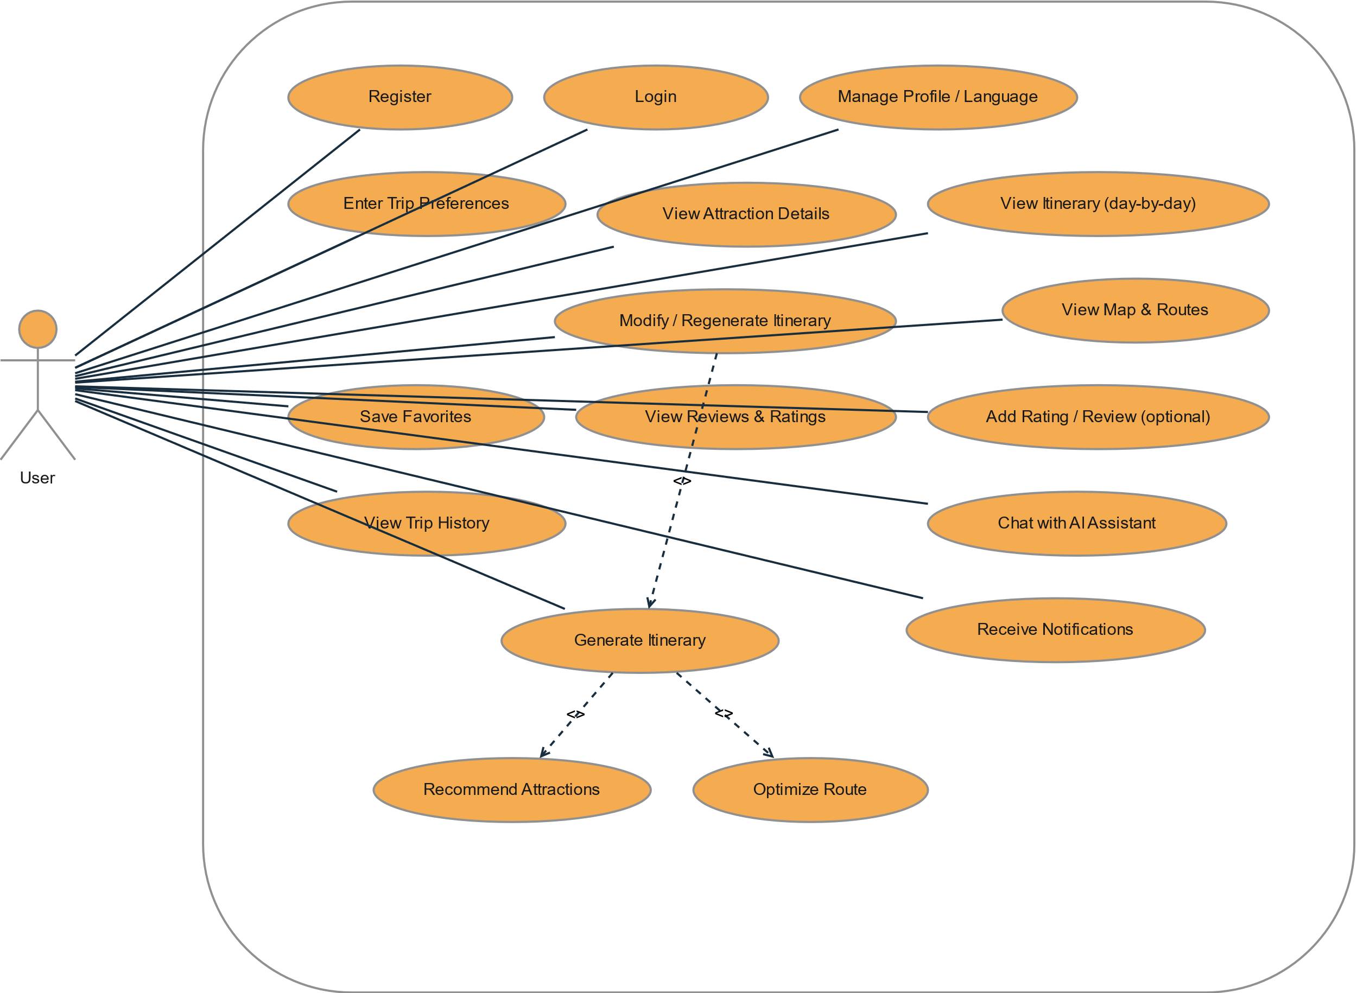
Figure 3.1 user use case diagram

Register
Field | Details
Primary Actor | User
Goal | Create a new account in the system
Preconditions | User is not logged in
Trigger | User selects “Register”
Main Flow | 1) Enter name/email/password 2) Choose language 3) System validates 4) System creates account 5) User is redirected/logged in
Alternate / Exceptions | Email already used → show error; weak password → request stronger password
Postconditions | New User record created; user can access the system

Login
Field | Details
Primary Actor | User
Goal | Authenticate and access the system
Preconditions | User has an account
Trigger | User selects “Login”
Main Flow | 1) Enter email + password 2) System validates 3) System creates session 4) User lands on home/dashboard
Alternate / Exceptions | Wrong credentials → error; account locked/inactive (if supported) → block login
Postconditions | User session active

Manage Profile / Language
Field | Details
Primary Actor | User
Goal | Update profile data and preferred language
Preconditions | User is logged in
Trigger | User opens Profile/Settings
Main Flow | 1) View profile 2) Edit name/email/language 3) Save 4) System validates and updates
Alternate / Exceptions | Invalid email format → error; email already used → error
Postconditions | Profile updated

Enter Trip Preferences
Field | Details
Primary Actor | User
Goal | Provide inputs to generate a suitable itinerary
Preconditions | User is logged in (or guest mode if allowed)
Trigger | User selects “Enter Trip Preferences”
Main Flow | 1) Choose destination city 2) Set duration 3) Set budget range 4) Select trip type 5) Add interests 6) Save preferences
Alternate / Exceptions | Missing required fields → prompt user; budgetMin > budgetMax → validation error
Postconditions | Preference + PreferenceInterest saved

Generate Itinerary
Field | Details
Primary Actor | User
Goal | Generate a day-by-day itinerary that matches preferences
Preconditions | Preferences exist (or user provides them during generation)
Trigger | User clicks “Generate”
Main Flow | 1) System loads preferences 2) System recommends attractions (includes Recommend Attractions) 3) System optimizes ordering/routes (includes Optimize Route) 4) System calculates estimated cost/time 5) System creates itinerary + days + items
Alternate / Exceptions | Not enough attractions → generate partial itinerary; external map/route service failure → fallback ordering
Postconditions | Itinerary stored and viewable
Relationships:
- <<include>> Recommend Attractions
- <<include>> Optimize Route

View Itinerary (day-by-day)
Field | Details
Primary Actor | User
Goal | View itinerary details organized by day
Preconditions | At least one itinerary exists
Trigger | User opens an itinerary
Main Flow | 1) System shows overview 2) User selects a day 3) System shows items with times and notes 4) User can open attraction details/map
Alternate / Exceptions | Itinerary not found → show error/empty state
Postconditions | View recorded in history (if tracked)

Modify / Regenerate Itinerary
Field | Details
Primary Actor | User
Goal | Change an existing itinerary and regenerate schedule/items
Preconditions | Existing itinerary exists
Trigger | User clicks “Modify/Regenerate”
Main Flow | 1) User edits preferences/constraints 2) System regenerates itinerary 3) System updates items/days and recalculates costs
Alternate / Exceptions | User cancels → no changes saved
Postconditions | Updated itinerary available

View Attraction Details
Field | Details
Primary Actor | User
Goal | See details for an attraction (info, hours, cost, etc.)
Preconditions | Attraction exists
Trigger | User selects an attraction
Main Flow | 1) System displays description/category 2) Show entry cost 3) Show opening hours 4) Show family-friendly flag 5) Show location
Alternate / Exceptions | Details missing → show partial info
Postconditions | None (or view tracked if needed)

View Map & Routes
Field | Details
Primary Actor | User
Goal | Visualize itinerary items and routes on a map
Preconditions | Itinerary exists; location data available
Trigger | User selects “View Map & Routes”
Main Flow | 1) System loads itinerary items 2) Plot pins 3) Draw route segments 4) Show travel times
Alternate / Exceptions | Map service unavailable → show list-only view
Postconditions | None

Save Favorites
Field | Details
Primary Actor | User
Goal | Bookmark attractions for later
Preconditions | User logged in; attraction exists
Trigger | User clicks “Save to Favorites”
Main Flow | 1) User selects attraction 2) System saves favorite 3) Favorites list updated
Alternate / Exceptions | Already favorited → no duplicate (or toggle remove)
Postconditions | Favorite record created/updated

View Reviews & Ratings
Field | Details
Primary Actor | User
Goal | See other users’ ratings and feedback for an attraction
Preconditions | Attraction exists
Trigger | User opens reviews section
Main Flow | 1) System loads review list 2) Show average rating 3) Show comments sorted/filterable
Alternate / Exceptions | No reviews → empty state
Postconditions | None

Add Rating / Review (optional)
Field | Details
Primary Actor | User
Goal | Submit a rating/comment for an attraction
Preconditions | User logged in; attraction exists
Trigger | User clicks “Add Review”
Main Flow | 1) User selects rating 2) Enter comment (optional) 3) Submit 4) System saves review and updates averages
Alternate / Exceptions | Invalid rating/out of range → error; profanity policy (if any) → block/edit
Postconditions | Review record created

View Trip History
Field | Details
Primary Actor | User
Goal | View previously generated/viewed itineraries
Preconditions | User logged in
Trigger | User opens “Trip History”
Main Flow | 1) System fetches history entries 2) Display list with dates 3) User opens a past itinerary
Alternate / Exceptions | No history → empty state
Postconditions | None

Receive Notifications
Field | Details
Primary Actor | User
Goal | Receive reminders/updates (trip reminders, seasonal tips, etc.)
Preconditions | User has notifications enabled (if applicable)
Trigger | Scheduled time reached or system event occurs
Main Flow | 1) System selects users 2) Sends notification 3) Marks as sent
Alternate / Exceptions | Delivery failure → retry/mark failed
Postconditions | Notification sentAt updated

Chat with AI Assistant
Field | Details
Primary Actor | User
Goal | Ask questions and get trip help (places, schedule tweaks, tips)
Preconditions | User in app; chat available
Trigger | User opens chat
Main Flow | 1) User asks question 2) System responds 3) User can apply suggestions to itinerary/preferences
Alternate / Exceptions | AI unavailable → show fallback help message
Postconditions | Chat history saved (if supported)

Recommend Attractions (Included)
Field | Details
Primary Actor | System (invoked by Generate Itinerary)
Goal | Select attractions matching preferences and constraints
Preconditions | Preference exists
Trigger | Called during itinerary generation
Main Flow | 1) Filter by city 2) Rank by interests/tripType/family 3) Consider cost and hours 4) Return list
Alternate / Exceptions | Too few results → relax constraints (optional)
Postconditions | Candidate attractions list produced

Optimize Route (Included)
Field | Details
Primary Actor | System (invoked by Generate Itinerary)
Goal | Order itinerary items to minimize travel time and fit schedule
Preconditions | Candidate attractions list exists; locations available
Trigger | Called during itinerary generation
Main Flow | 1) Build route plan 2) Compute travel times 3) Assign items per day 4) Output ordered itinerary items
Alternate / Exceptions | Route service fails → heuristic ordering
Postconditions | Ordered route + travelTimeFromPrev values produced
Secondary Use Case: Manage Attractions
Actor: Administrator
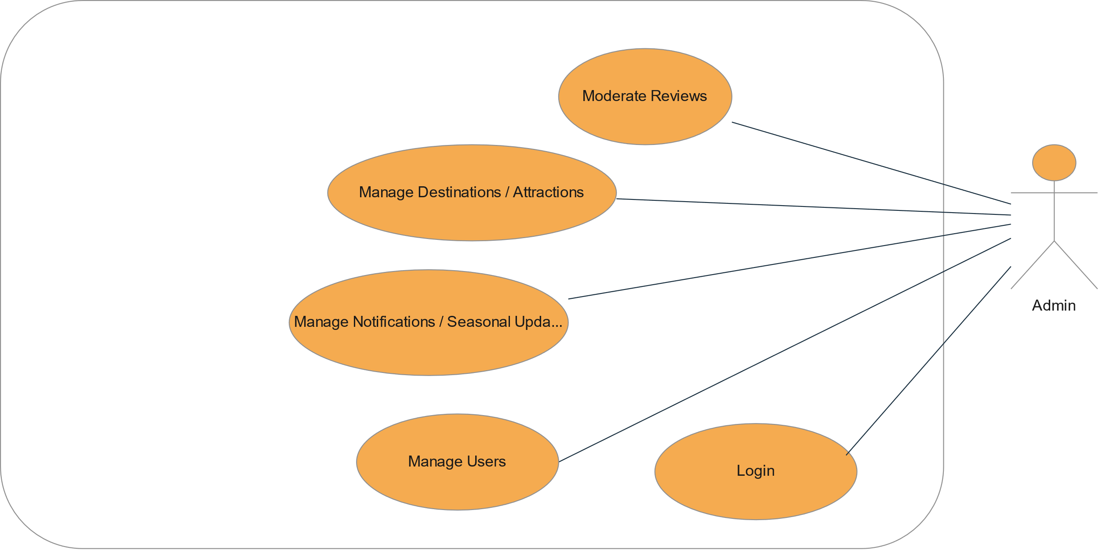
Figure 3.2 Admin use case diagram
use case 1: admin login
field | description
use case name | admin login
primary actor | administrator
goal | authenticate administrator and grant access to admin dashboard
preconditions | administrator account exists in the system
trigger | administrator enters username and password
main flow | 1. admin enters credentials
 | 2. system validates username and password
 | 3. system creates secure session
 | 4. admin is redirected to dashboard
alternate flow | invalid credentials → system displays error message
postconditions | admin session is active
use case 2: manage users
field | description
use case name | manage users
primary actor | administrator
goal | add, edit, view, or deactivate user accounts
preconditions | admin is logged in
trigger | admin selects “user management” module
main flow | 1. admin views list of users
 | 2. admin selects add, edit, or deactivate option
 | 3. system validates input
 | 4. system updates database
alternate flow | invalid input → system shows validation error
postconditions | user records updated successfully
use case 3: manage attractions
field | description
use case name | manage attractions
primary actor | administrator
goal | add, edit, or delete tourist attractions
preconditions | admin is authenticated
trigger | admin selects “attraction management”
main flow | 1. admin enters attraction details
 | 2. system validates data
 | 3. system stores or updates attraction record
alternate flow | missing required fields → error displayed
postconditions | attraction database updated
use case 4: manage reviews
field | description
use case name | manage reviews
primary actor | administrator
goal | moderate or remove inappropriate reviews
preconditions | admin is logged in
trigger | admin selects “review management”
main flow | 1. admin views list of reviews
 | 2. admin selects review
 | 3. admin deletes or approves review
alternate flow | no reviews available → display empty state
postconditions | review records updated

CHAPTER 4
SYSTEM DESIGN

4.1 Introduction
System design is a critical phase in the software development life cycle. After defining the system requirements in the analysis phase, the design phase translates those requirements into a structured technical blueprint. The objective of system design is to define system architecture, data structure, component interactions, and overall system behavior.
Wajhati Saudiya is designed as a web-based smart tourism application that follows a modular and scalable architecture. The design focuses on separation of concerns, maintainability, security, and performance efficiency. The system integrates frontend components, backend services, database management, and external APIs such as mapping services.
This chapter presents the system architecture, structural static models, and dynamic models that describe how the system components interact to achieve the project objectives.

4.2 Structural Static Models
The structural static model represents the static structure of the system using a class diagram. The class diagram illustrates the system’s main classes, their attributes, methods, and relationships.

4.2.1 Class diagram
Displays the classes used in the system and collaboration and their relationships, as each class contains three elements: the class name, the Attributes, and the operations. The class diagram is the main building block of object-oriented modeling. It is used for general conceptual modeling of the structure of the application, and detailed modeling translating the models into programming code. Class diagrams can also be used for data modeling.
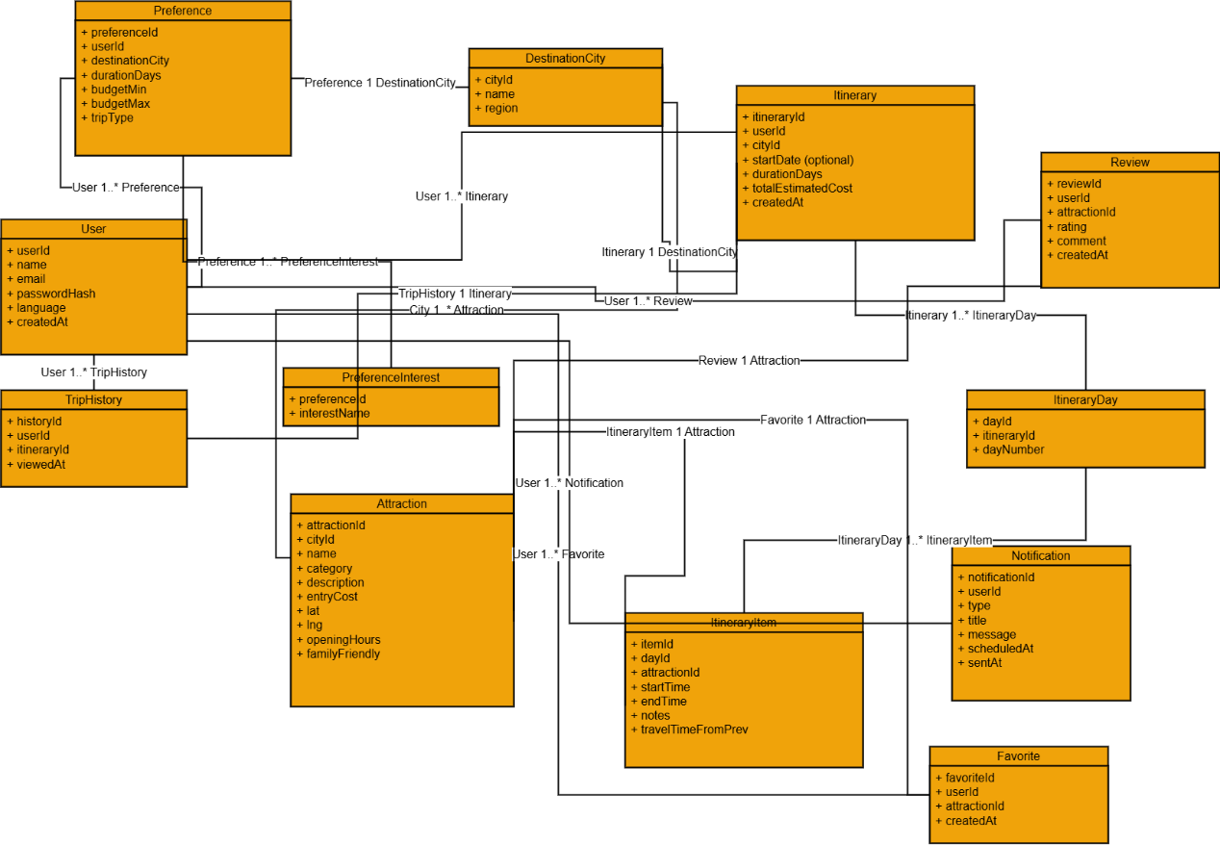
Figure 4.1 Class diagram

4.3 Dynamic Models
The dynamic model is used to express and model the behavior of the system over time. It includes support for activity diagrams, state diagrams, sequence diagrams, and extensions including business process modeling.

4.3.1 Sequence diagram
A sequence diagram simply depicts the interaction between objects in sequential order i.e. the order in which these interactions take place. We can also use the terms event diagrams or event scenarios to refer to a sequence diagram. Sequence diagrams describe how and in what order the objects in a system function. These diagrams are widely used by businessmen and software developers to document and understand requirements for new and existing systems.
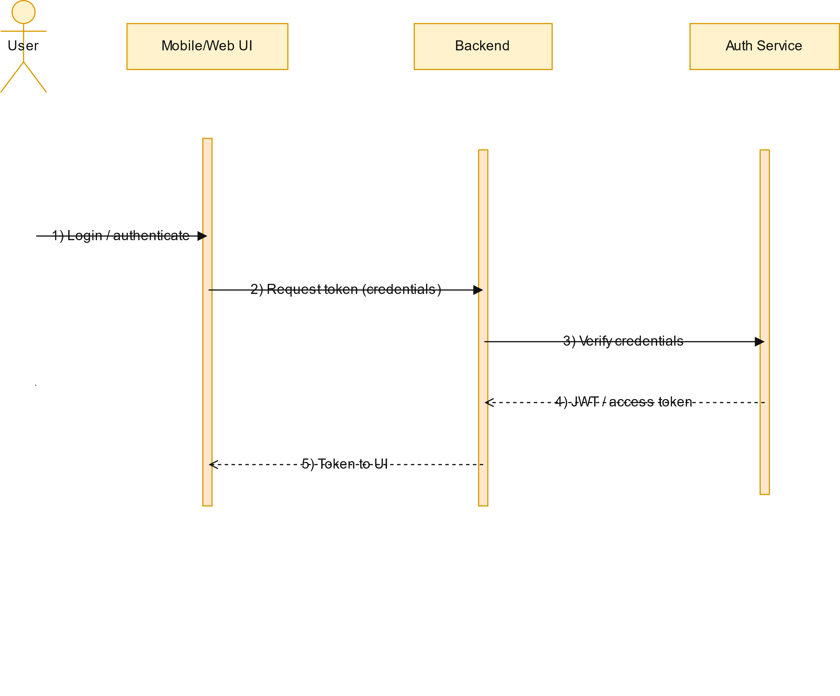
Figure 4.2 Login sequence diagram

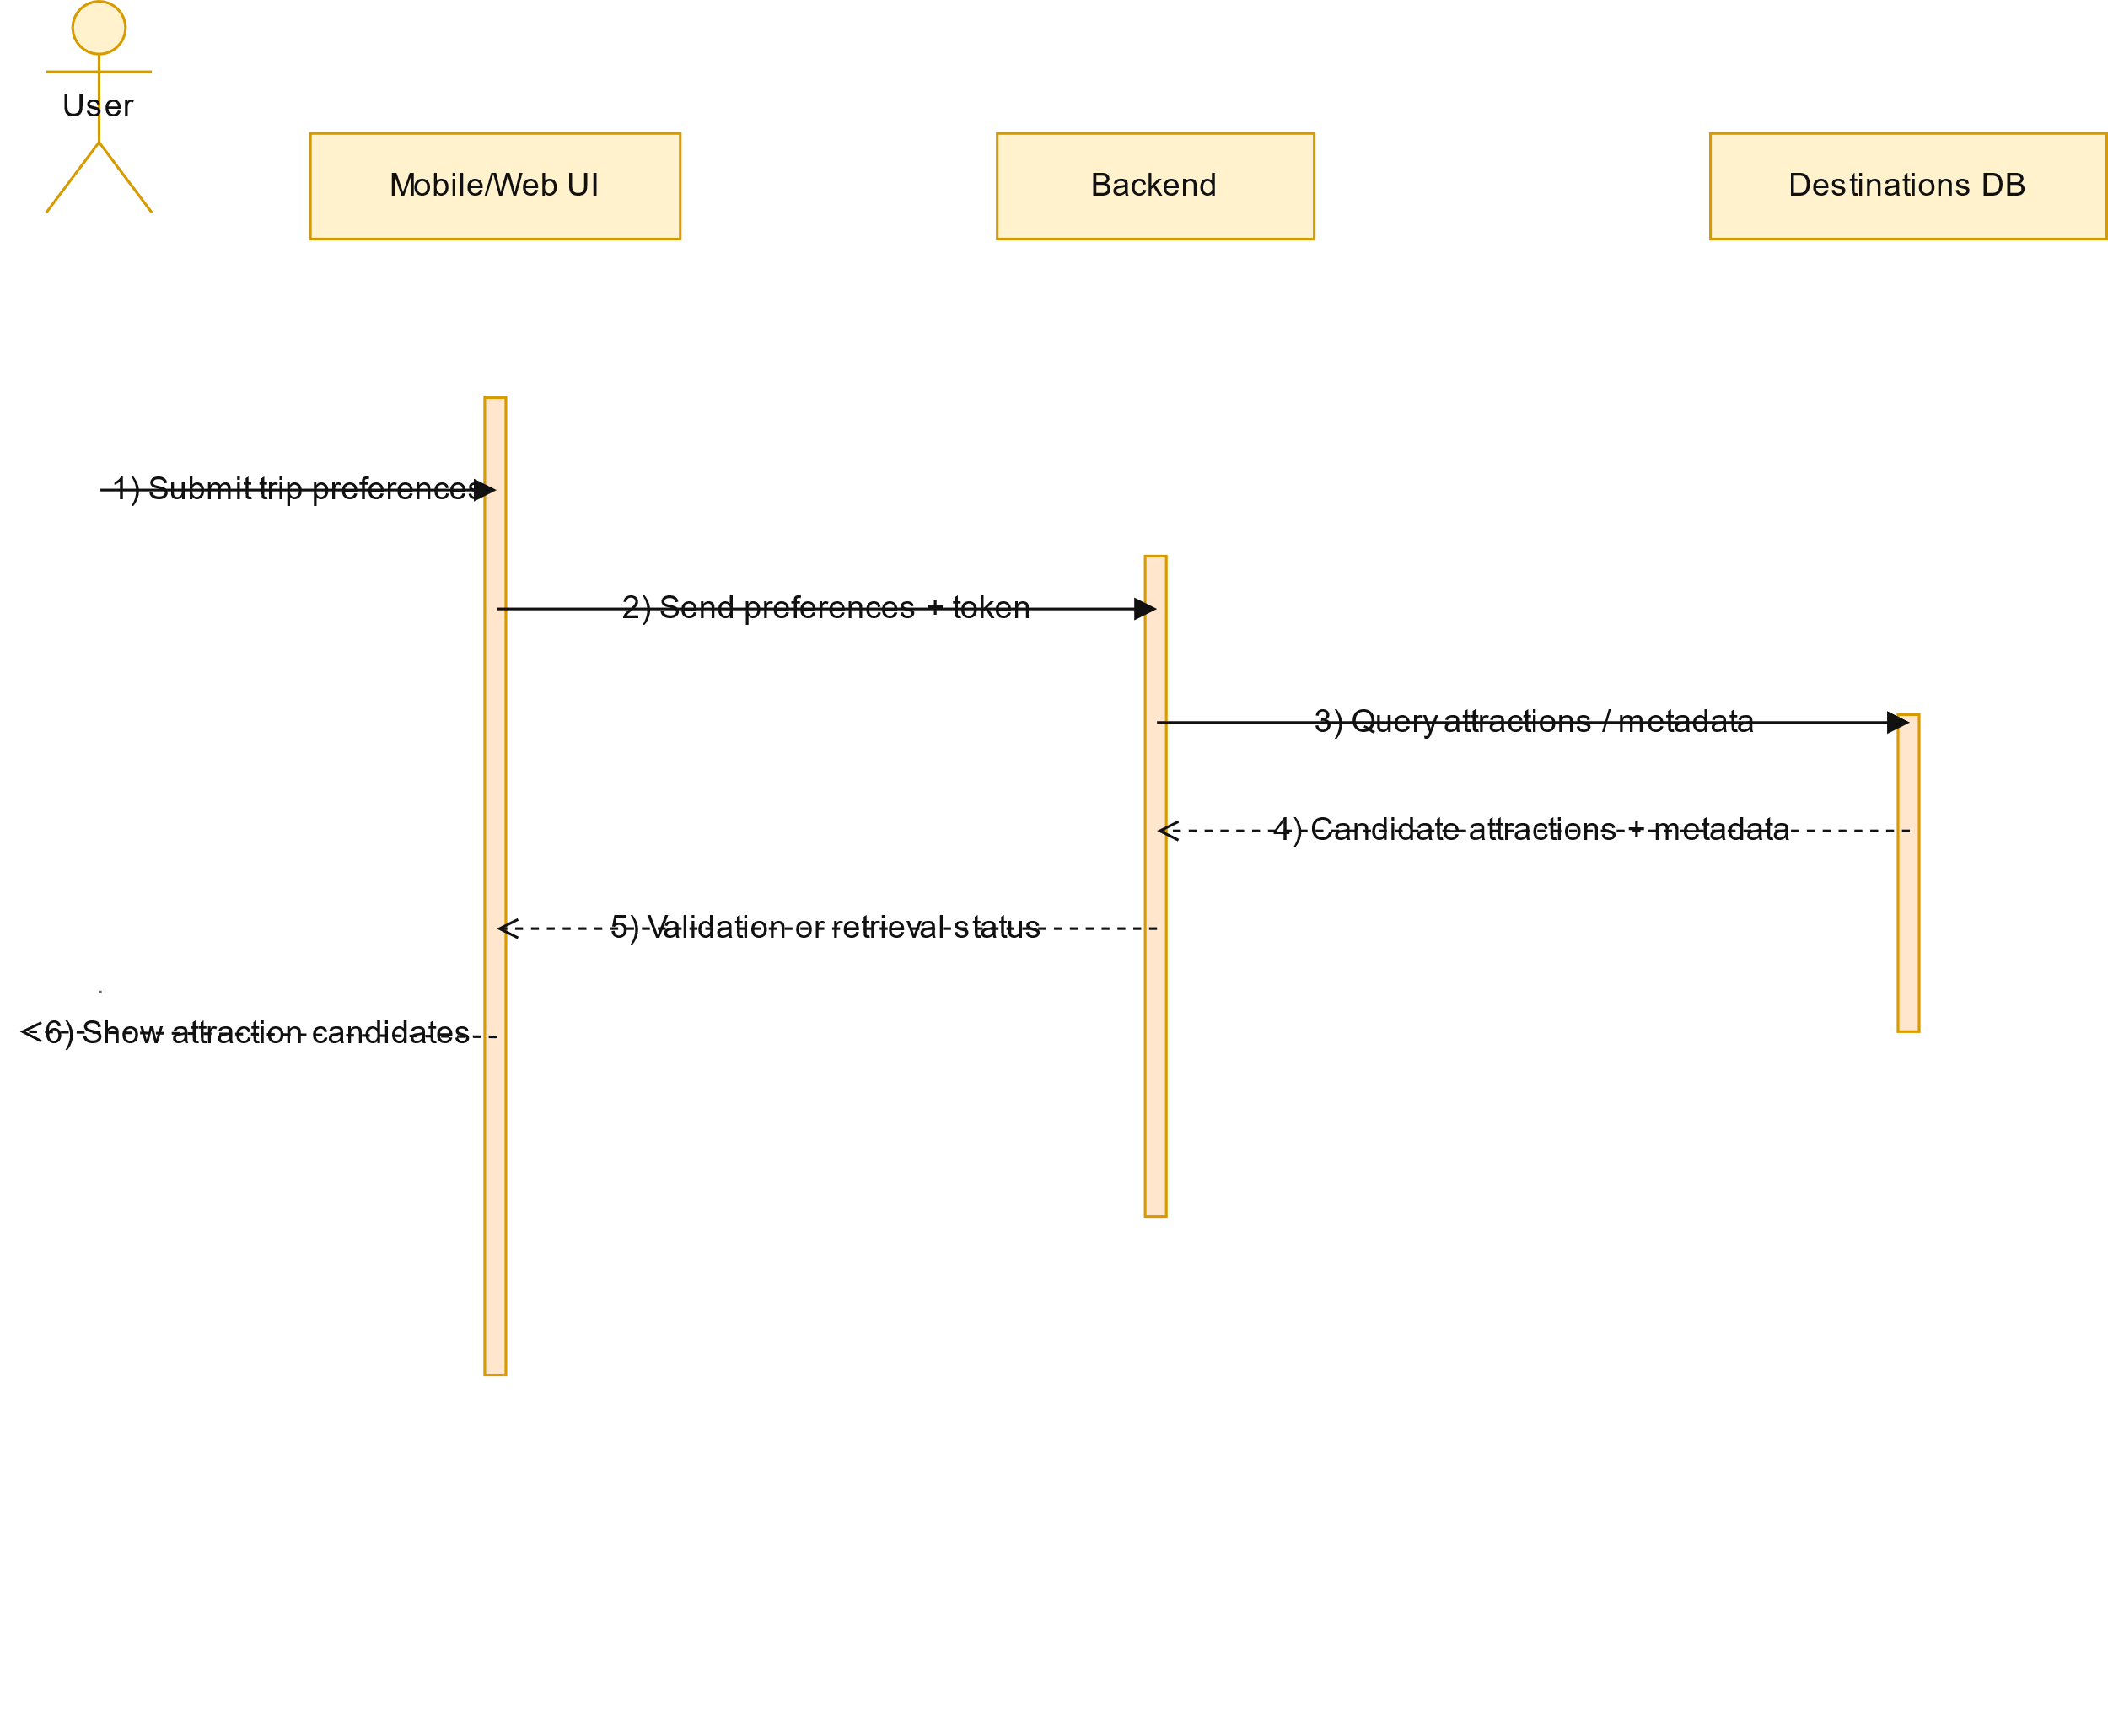
Figure 4.3 User add preferences-and-attractions record sequence diagram

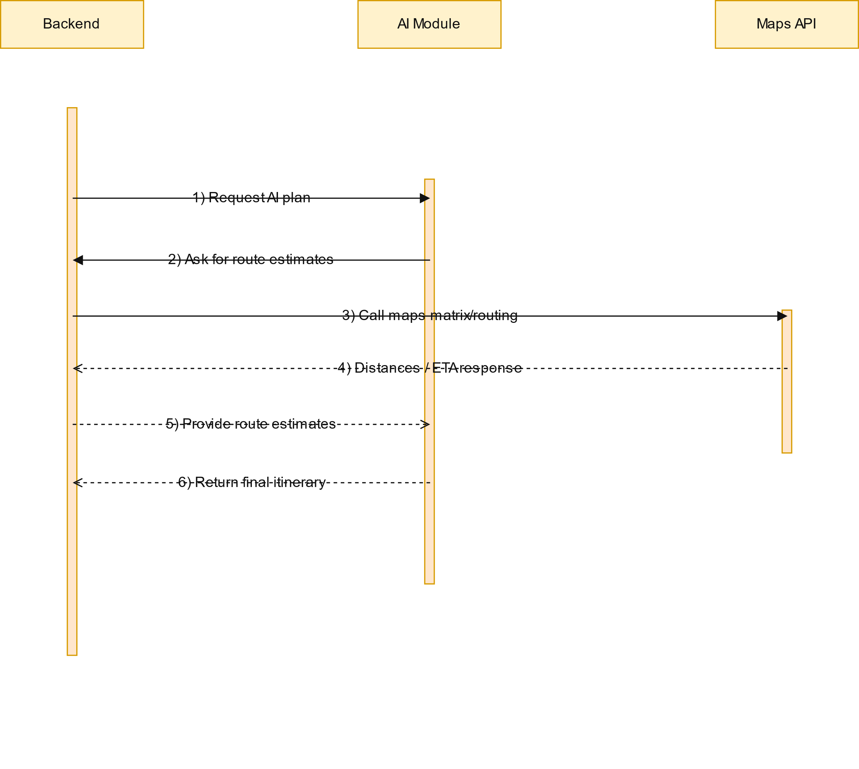
Figure 4.4 routing-and-ai sequence diagram

4.3.2 Activity Diagram
Activity diagrams are graphic representations of the workflow of activities and stepwise actions with support for selection, repetition, and concurrency.

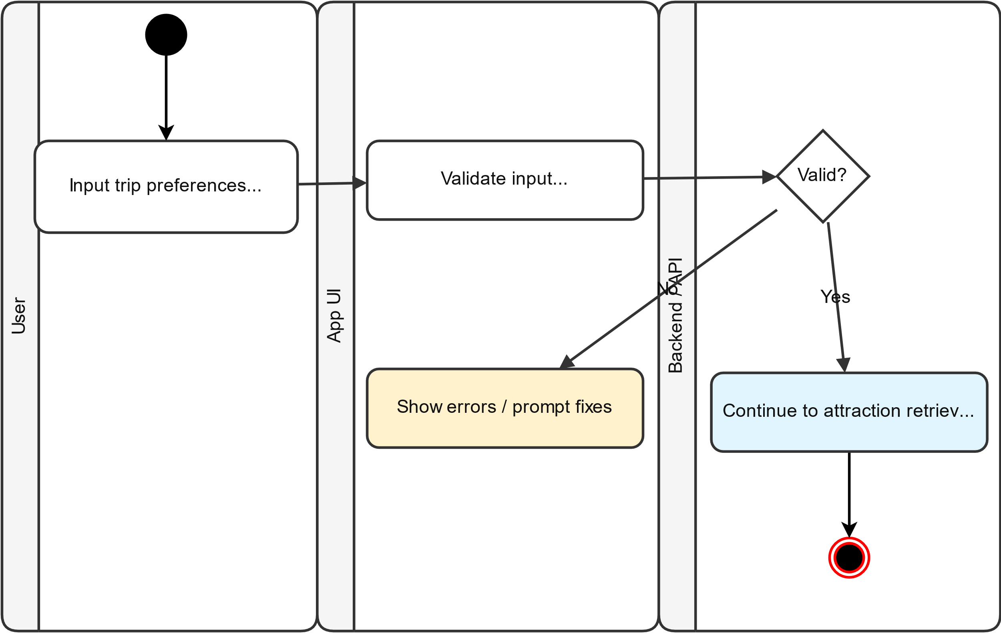
Figure 4.7 input validation diagram

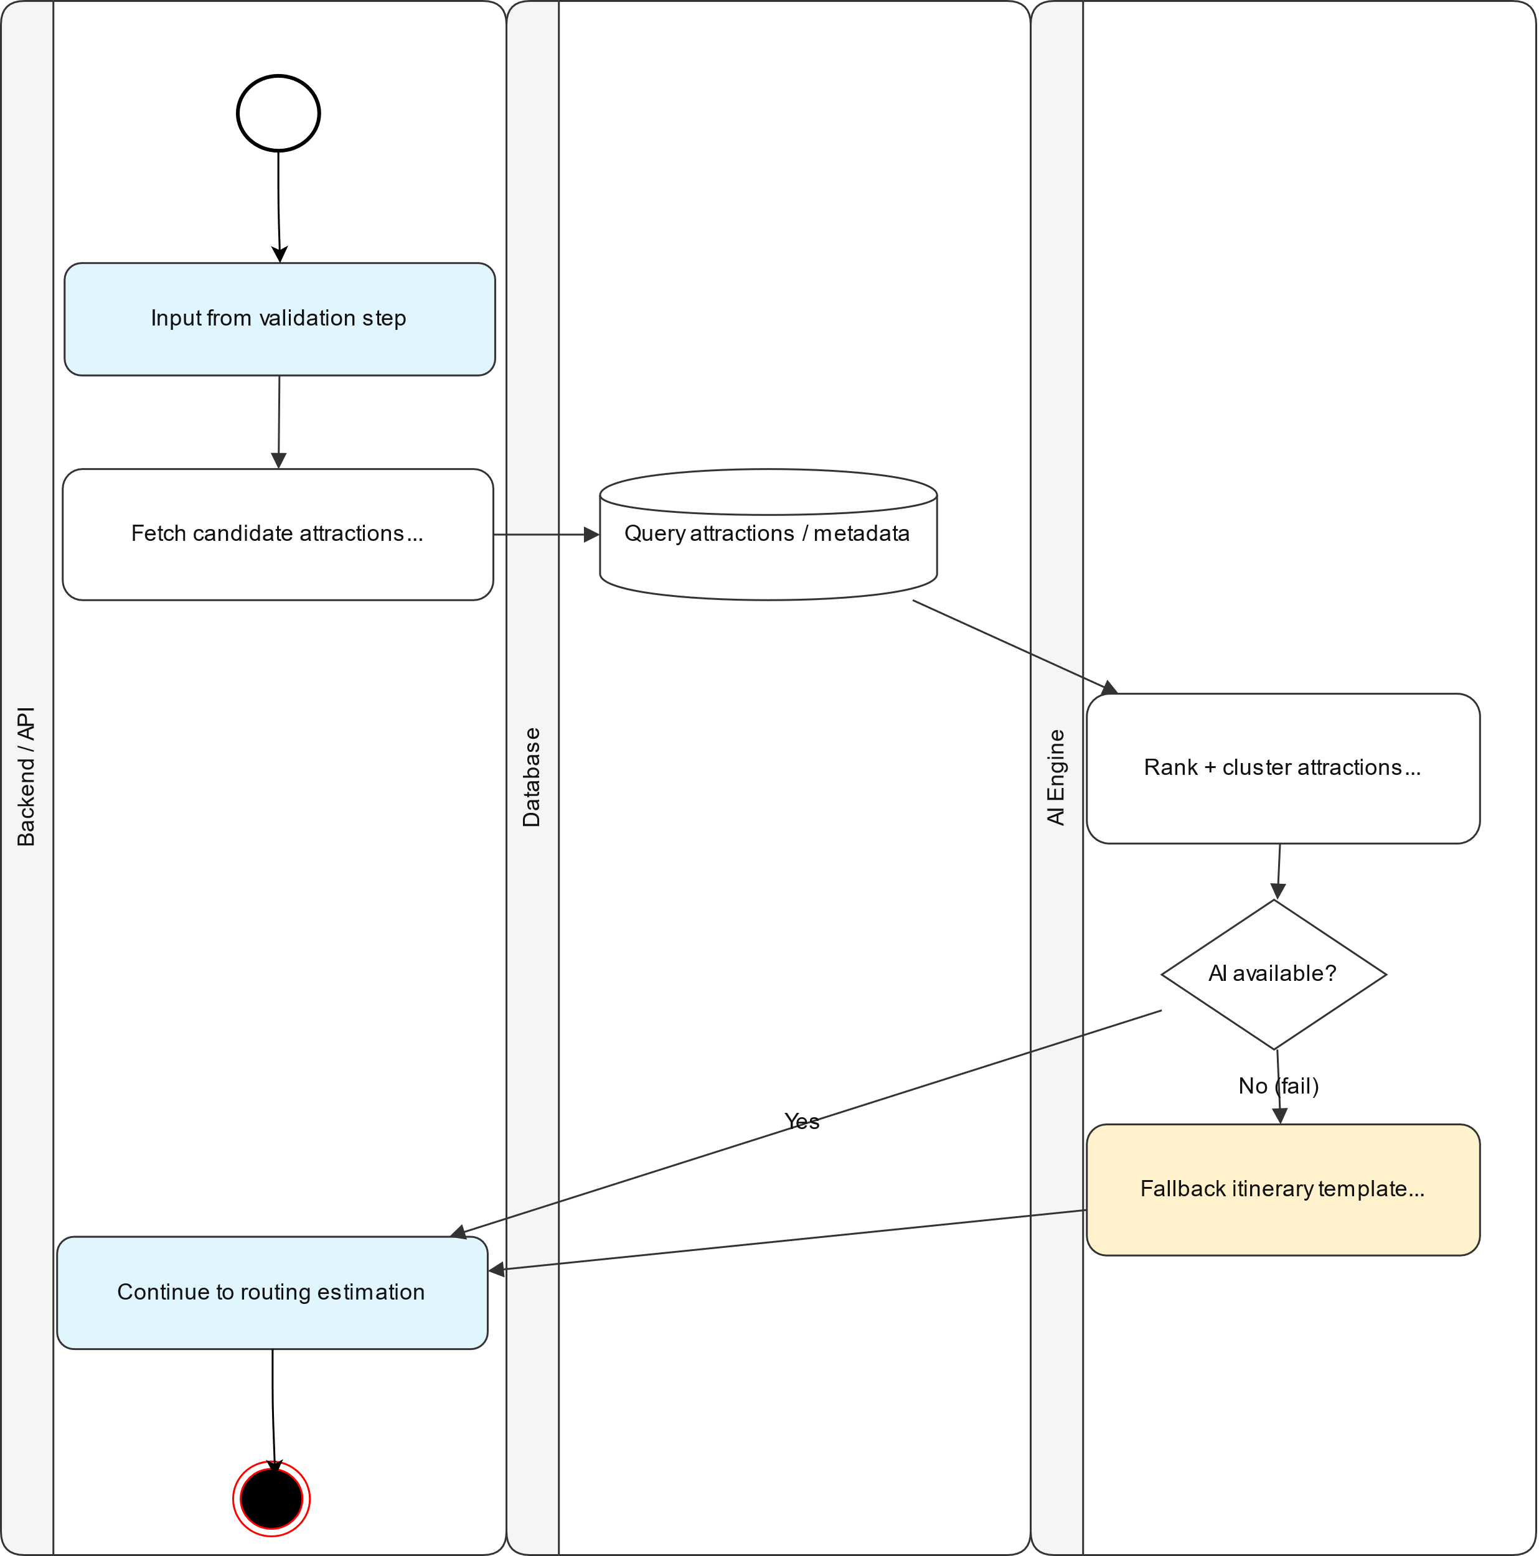
Figure 4.8 attraction-ranking diagram
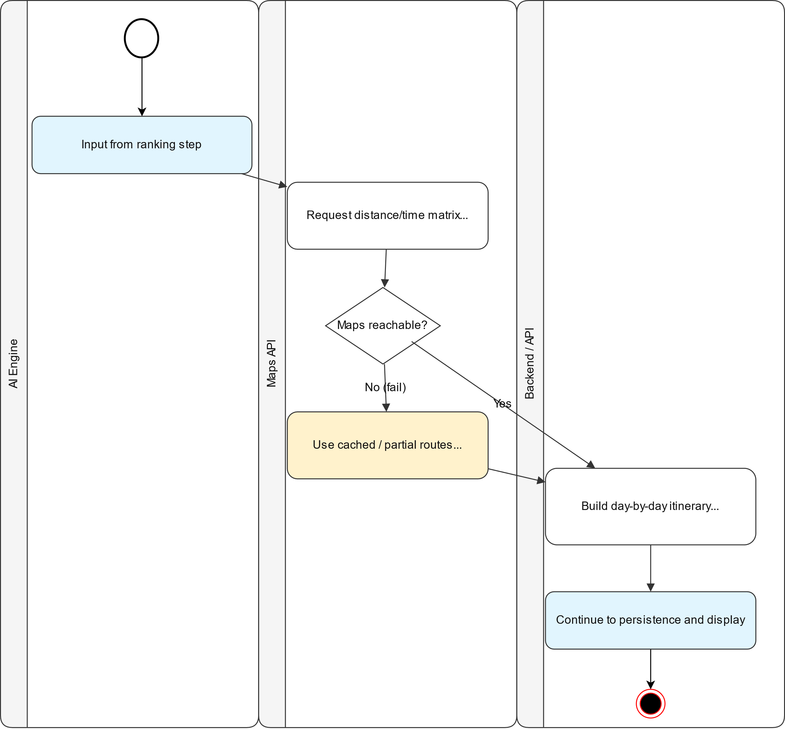
Figure 4.9 save itinerary record diagram

.

